National Information Centre for Indian Languages
Central Institute of Indian Languages, Manasagangotri, Mysore – 570 006

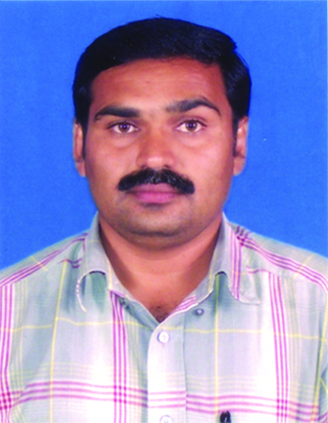
1. Name in full (Block Letters please)
with photo : DR. M. RAMAKRISHNAN

2. Nationality : INDIAN
3. Address:
(a) Official : ASSOCIATE FELLOW
DEPT OF HISTORY, SOCIOLOGY & ANTHROPOLOGY
CENTRAL INSTITUTE OF CLASSICAL TAMIL
IRT CAMPUS – TARAMANI
CHENNAI – 600 113 (Tamil Nadu)

(b) Residential (Native) : 6/81, DR. AMBEDKAR STREET
UREMELALAGIAN
AYIKUDI POST
TENKASI TALUK, TIRUNELVELI DIST
627852 (Tamil Nadu)

(Chennai) : 3/112, BHARATHI STREET
VETTUVANKENI (KANCHIPURAM DIST)

CHENNAI – 600115
(c) Email Id : ilakkiyameen@gmail.com/ rediffmail.com
(d) Contact No. Residence/Office
/Mobile : 9043158751 / 9444868577

4. Place and date of birth : UREMELALAGIAN – 15-07-1971
5. Mother tongue : TAMIL
6. Languages known : TAMIL, MALAYALAM, HINDI, ENGLISH

7. Educational qualifications/Degrees
Acquired with University and year : University Year
(a) M. A. : M.S. UNIVERSITY, TIRUNELVELI 1994
(b) M.Phil : JNU, NEW DELHI 1997
(c) Ph.d Title (Specify Title/year
awarded) : JNU, NEW DELHI 2002

(CONCEPTUALIZATION AND CONFIGURATION OF BODY, EMOTION AND KNOWLEDGE IN NARRATIVE DISCOURSES WITH REFERENCE TO TAMIL BALLADS)

(d) Any other : UGC’s JUNIOR RESEARCH FELLOWSHIP
(Sl. No. 408/JRF (SC/ST) (June 1994) Roll No. A 490 712)
POST DOCTORAL FELLOW (IN CLASSICAL TAMIL, UNDER CECT, CIIL, MYSORE, 2006-7)
8. Positions held:
(a) Present : ASSOCIATE FELLOW
CENTRAL INSTITUTE OF CLASSICAL TAMIL
CHENNAI

(b) Previous : PROJECT OFFICER
CENTRE FOR FOLKLORE STUDIES
UNIVERSITY OF CALICUT, KERALA

PROGRAMME OFFICER
NATIONAL FOLKLORE SUPPORT CENTRE
CHENNAI

EXECUTIVE DIRECTOR
NATIONAL FOUNDATION FOR ARTS,
CULTURE & DEVELOPMENT
CHENNAI

9. Details of awards / honours received : PRESIDENTIAL AWARD FOR YOUNG SCHOLAR
If any IN CLASSICAL TAMIL FOR THE YEAR 2008-2009

PRIZE MONEY AWARD FOR DISTINCTION IN PG FROM GOVERNMENT OF TAMIL NADU

10. Teaching experience (Course normally : INTRODUCTION TO SOCIOLINGUISTICS,
taught STUDY SKILLS – IN JNU FOR BA & MA STUDENTS & THEORETICAL FOLKLORE, SEMIOTICS IN CENTRE FOR FOLKLORE STUDIES, UNIVERSITY OF CALICUT, KERALA FOR PG & MPHIL STUDENTS.
(IN TOTAL 3 YEARS)

11. Research experience (research areas : IN TOTAL 12 YEARS EXCLUDING MPHIL &
undertaken PHD PERIOD)
FOLKLORE, CULTURAL EXPRESSIONS, ANCIENT TAMIL LITERATURE, COGNITIVE STUDIES, SEMIOTICS OF CREATIVE PROCESS
GLOBALIZATION FROM LINGUISTIC POINT OF VIEW, SUBALTERN STUDIES ETC.
12. Area of specialization:
(a) Have you received any special/ :YES. IN FOLKLORE FROM ST. XAVIER’S advanced training ? If so, please COLLEGE, PALAYAMKOTTAI – TWO YEARS + 1
mention the place, where the MONTH REFRESHER COURSE
training was obtained and in which
area and the duration of the SEMIOTICS IN JNU
training.

WEBDESIGNING FROM BRITISH COUNCIL LIBRARY

WORLD ROCK ART PAINTINGS – IGNCA NEW DELHI

ANCIENT TAMIL LITERATURE – CICT CHENNAI

13. Research guidance:
(a) Theses guided :

(b) Research projects guided : 1. C. Sreela – Lores and Myths of Todas
2. V.P. Vimal Kumar – Potential of Folk Art
Forms for Tourism Development: A Study
based on Malabar and Nilgiris Region
3. Shilet Cijo – The Todas: Life and Culture
– Today and Yesterday
4. J.R. Krishnendu – The Todas: Customs
and Rituals
(Under Aspire Fellowship programme for PG for the period 2011-2012 at Centre for Folklore Studies, University of Calicut)
14. Countries visited:
(a) Purpose of visit and duration of : Nil
stay ( Please furnish full details)

15. Special Lectures delivered : five lectures at Centre for Folklore Studies,
University of Calicut

16. Membership of learned societies : Indian Folklore Congress
FOSSILS
International Research Institute of Tamil
Language, Philosophy and Culture, Trichy
Thenpodhigai Tamil Sangam, Tenkasi
National Foundation for Arts, Culture &
Development, Chennai

17. Publications :1. Kural as Universal Schemata : Language, Culture
and Cognition (2008) (Received Presidential
Award for 2008-2009)
2. Kathaignarum Kathaikalum, Karusamuthu Ammal – Uremelalagian (2006, reprint in 2010)
3. Punjabi Folktales (Translation) (2010)
4. Life of Senior Citizens – Lores and Concerns (co-authored by Prof. E.K. Govinda Varma Raja,
Head, School of Folklore Studies, University of
Calicut) (2011)
5. Chemmozhi Selvam – Prof. Ku.Sivamani’s 80th Birthday Felicitation Volume ( co-edited by Prof. K. Ramasamy and Prof. P. Marudanayagam) (2011-12)
6. Essays on Classical Tamil (coedited with Prof. P.
Marudanayagam & Prof. Ku. Sivamani)

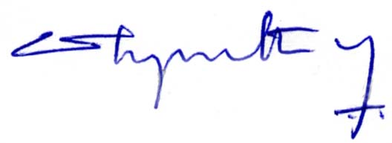

(DR. M. RAMAKRISHNAN)

